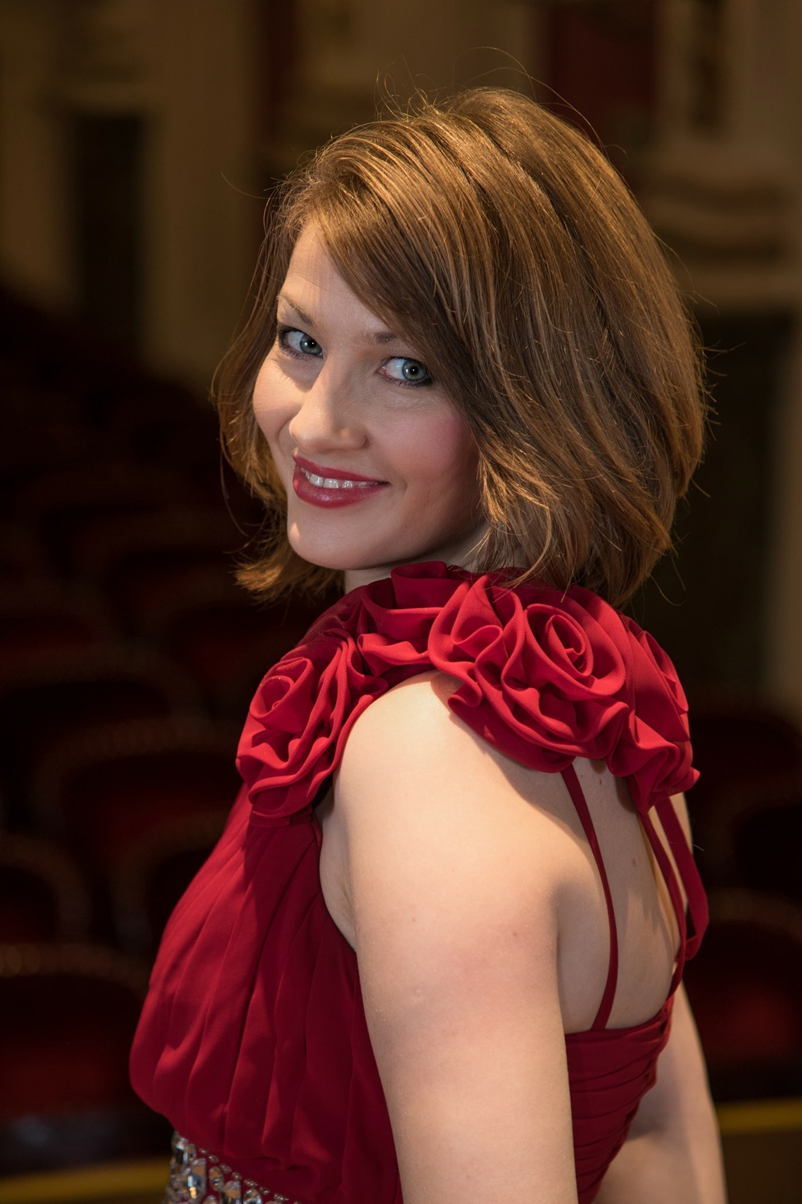
Russian pianist Anna Fedorova-Latso has been called “powerful and seductive” by the Desert Entertainment and praised for her “noble tone and expressive poetry” by Wiener Blätter.
Anna developed as an artist with deep Russian musical tradition known and recognised around the world. Starting at the young age of six, Anna was quickly noticed by famous Russian pianist and pedagogue Vera Gornostayeva. This later led to her studies at the Glinka Nizhegorod State Conservatory under Prof. Valery Starinin and Prof. Ekaterina Flerova where in addition to the Vladimir Krainev Foundation scholarship, she was awarded the highest honors and a prize for her extraordinary achievements during the studies.
She has participated from an early age in national and international music competitions. At the age of eleven as the youngest participant, she won the second prize at the Russian Youth Piano Competition in Dubna. She further went on to win the Maria Cherogiorgou-Sigara International Piano Competition in Athens, International Piano Competition Città di Ovada in Italy, Maria Yudina International Piano Competition in St. Petersburg, Scriabin International Piano Competition in Grosseto and the International Piano Competition in Santorini.
As an accomplished soloist, she he has performed numerous times with the Nizhny Novgorod Philharmonic and with the “Soloists of Nizhny Novgorod” Chamber Orchestra. She is an active recitalist and keen chamber musican and has performed extensively across her native Russia, Europe, the USA and Asia. Moreover, Anna was invited by the Russian Embassy in Greece and the Greek Minister of Culture to represent Russia by performing at the “Russian Week Festival” in Corfu.
Anna further enriched her musical understanding and expanded her technique at the masterclasses with Dmitri Bashkirov, Vladimir Krainev, Robert Lehrbaumer, Martino Tirimo, Helena Muzalas, Andrei Diev, Maxim Mogilevsky and Alexander Bonduriansky. This was followed by her moving to Vienna and undertaking postgraduate studies at the Prayner Conservatory of Music and Dramatic Arts with Prof. Robert Lehrbaumer. Since then, she regularly plays solo concerts in Austria and is a member and often a soloist of the Vienna Residence Orchestra. In addition, she performs regularly as a soloist, chamber musician and accompanist of instrumentalists and singers at the Vienna State Opera.
With her husband, the American-Georgian pianist Giorgi Latso, she founded “The Latsos” Piano Duo, the recent winner of Beverly Hills National Auditions. Their repertoire includes all major works for four-hand piano and 2-piano duos as well as numerous forgotten original transcriptions and 20th century works. The Latsos has performed in numerous European countries as well as in Russia and the USA. Moreover, the duo has been recently invited by legendary pianist Maria João Pires to perform at the Belgais Center for Arts in Portugal.

