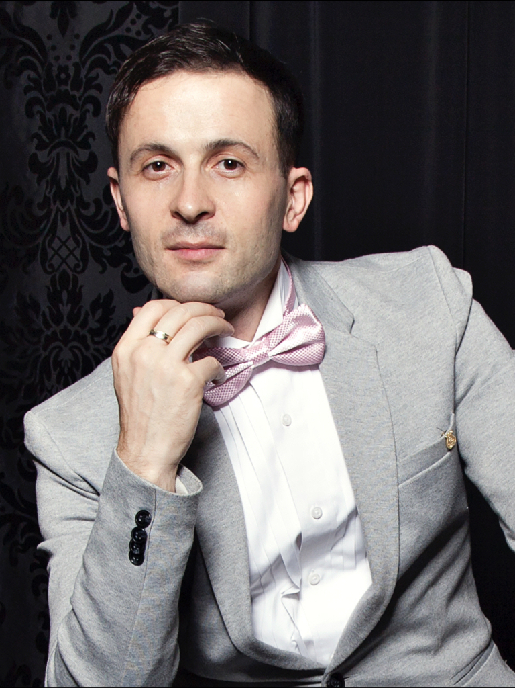
Georgian-American pianist Giorgi Latso has been called “a magician of impeccable technique” and simply “magnificent” by Liechtensteiner Volksblatt. The Los Angeles Times praises his "internal wealth and ‘aristocratic' spirit” and Lie: Zeit his "transcendental technique and depth of musical thinking”.
After playing Beethoven’s Emperor Concerto at WUK Kulturhaus Der Standard hailed him as “a technically brilliant pianist imbued with touching lyricism and genuine depth”. This electrifying performance led to an invitation by Pope Benedict XVI to play Mozart’s Piano Concerto No. 21 with the Vienna Philharmonic at the Basilica di Santa Maria Maggiore in Rome and a private audience at the Vatican. Other major concert highlights include Vienna’s Konzerthaus, Gewandhaus in Leipzig, London’s Wigmore Hall, Disney Hall in Los Angeles, NY Kaufman Concert Hall, Taipei National Concert Hall, Bunkamura Orchard Hall and Berliner Philharmonie, after which Berliner Kurier described him as an “extremely imaginative and mature artist with extraordinary musical intelligence”.
As a passionate recording artist, Giorgi “has an ability to interpret any repertoire he chooses with great sense of style and emotional depth” as reveals Mezzo Magazine. Among his landmark albums are Chopin’s 24 Preludes, Liszt's 12 Transcendental Études as well as Debussy’s 24 Préludes, for which Rhinegold’s Classical Music praised his “extraordinary imagination and a musical tone rarely heard”. NAXOS’ Waghalter Album, which he recorded with the Royal Philharmonic Orchestra and violinist Irmina Trynkos under the baton of Alexander Walker, won Pizzicato’s coveted Supersonic Award. Latso, also a sought-after composer, is a winner of the Best Music Award at the Bologna Film Festival for his music for “Waltz-Fantasy"
Named one of Georgia’s “Top 10 International Public Personalities” he is a regular guest on radio and TV including BBC 3, Rai Radio Classica, BR-KLASSIK, Imedi TV, Rustavi TV, and Iberia TV, which featured him on “Open Studio”. Moreover, the documentary “On the steps of Mozart” about his life was produced by KTV Austria and broadcasted across Europe.
He holds a professorship at the Prayner Conservatory of Music and Dramatic Arts. Since 2013, Giorgi is honoured to be a Steinway Artist.
More info on www.giorgilatso.com.

